THE POLYTECHNIC, IBADAN.

DEPARTMENT OF COMPUTER STUDIES

COURSE TITLE: PYTHON PROGRAMMING LANGUAGE (COM315)

LEVEL: HND1

LECTURER IN CHARGE: MRS. ONI

QUESTION: A PYTHON PROGRAM TO DEVELOP A UNIFORM RESOURCE LOCATOR (URL)

PYTHON GROUP 6 ASSIGNMENT

|  |  |  |
| --- | --- | --- |
| **S/N** | NAME | MATRIC NO. |
| 1 | AJIBADE TOYYIB BABATUNDE | F2312238 |
| 2 | AGBAJE SUNMISOLA MARY | F2306107 |
| 3 | OLANREWAJU KAFAYAT MOGBOJUBOLA | F2309795 |
| 4 | OGUNWOLE OLAMIDE JOHN | F2301691 |
| 5 | AKINTAYO KAFILAT TITILOLA | F2313018 |
| 6. | ADEWUMI EUNICE BOLA | F2314191 |
| 7 | OWOLABI RODIAT ABIODUN | F2313030 |
| 8. | ADETORO SEUN AUGUSTINE | F2305464 |
| 9 | AKINBODE FEYISHOLA SAMUEL | F2311684 |
| 10 | ADEDAPO ABIODUN JOSEPH | 2019235020021 |
| 11. | FADIRAN TAIWO DEBORAH | F2302979 |
| 12. | OYENUGA KABIRAT TEMITOPE | F2305285 |
| 13 | AWOYOMI OLUMUYIWA ANTHONY | 2023215020022 |
| 14 | SALAUDEEN QUDUS AJIBOLA | 2023215020014 |
| 15 | ALANI BARAKAT ADENIKE | 20190705010090 |

**PRACTICAL PROCEDURES**

**AIM OF PRACTICAL**

A python program to develop a Uniform Resource Locator (URL)

**PERFORMANCE OBJECTIVE**

1. Effectively generate short URLs for long links
2. Minimize the time it takes to redirect users to the original URL
3. Allow users to create custom URLs quickly
4. Protect against abuse, spam, and unauthorized access
5. Ensure fast and responsive URL redirection

**DESCRIPTION OF THE PROGRAM DEVELOPED**

1. Installation of python3 compiler
2. Installation of Pyshortener module which is responsible for URL shortening
3. Installation of Pyperclip which makes the link clickable
4. Installation of PyCharm IDE (text editor)

**EXPECTED RESULT**

The generated link is expected to redirect the you to the original link provided by the user

**GENERAL OBSERVATION**

Generating a short URL can make links more user friendly, easier to share, and visually cleaner. Short URLs are especially useful in character-limited spaces like media posts an can enhance click-through rate. In conclusion, they provide a level of anonymity, as users can not discern the destination from the URL alone.

CODE

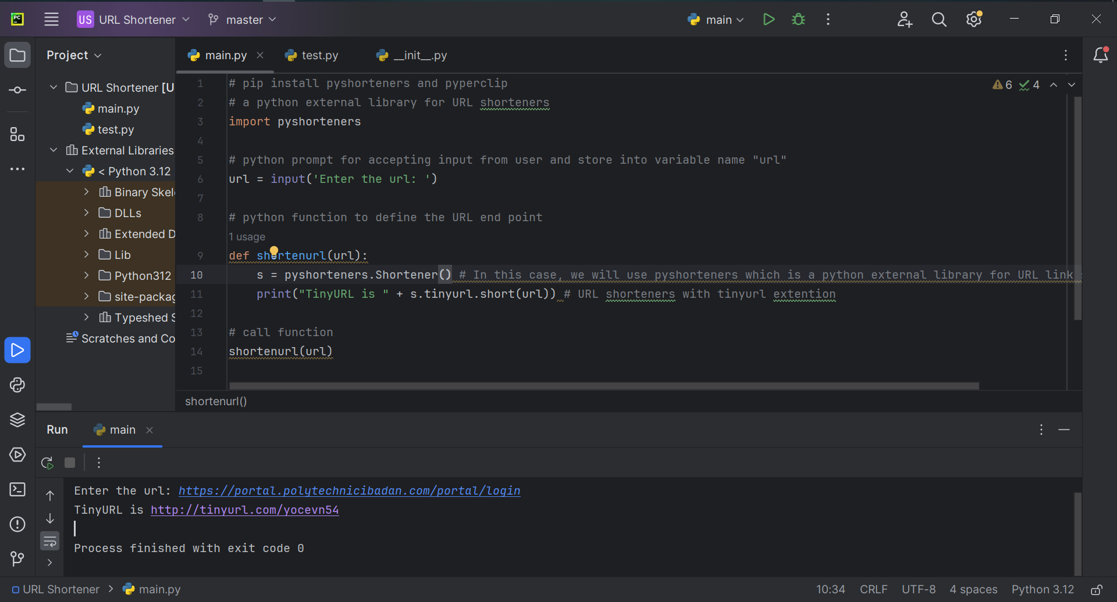

Interted link: https://portal.polytechnicibadan.com/portal/login

Shortened link: http://tinyurl.com/yocevn54

OUTPUT

